**Recommended Action**

|  |  |  |  |  |
| --- | --- | --- | --- | --- |
| **Service** | **RA ID** | **RA Name** | **RA Owner** | **Contacts** |
| [Authorization & Trust Management Service - XSUAA](https://jtrack.wdf.sap.corp/browse/SERVICE-92) | <ID> | Authorization and Trust Management Service – XSUAA Availability | Lyubomir Minchev  Donyo Donev | [DL CP XSUA OPS](mailto:cp_xsuaa_ops@sap.com) |

**Description**: This alert is raised in case of problems with authorization and trust management Availability

# **Steps to identify the issue via Browser**

1. **Check Münchhausen monitoring in Grafana**

Navigate via browser to the following URL which shows All CF Landscapes XSUAA basic status :  
в <https://cfops-dashboard.dmzmo.sap.corp/d/C5-G42pmk/xsuaa-munchhausen-monitoring?orgId=1>

Based on the received alert - choose the respective Landscape, which is reported in the ticket.

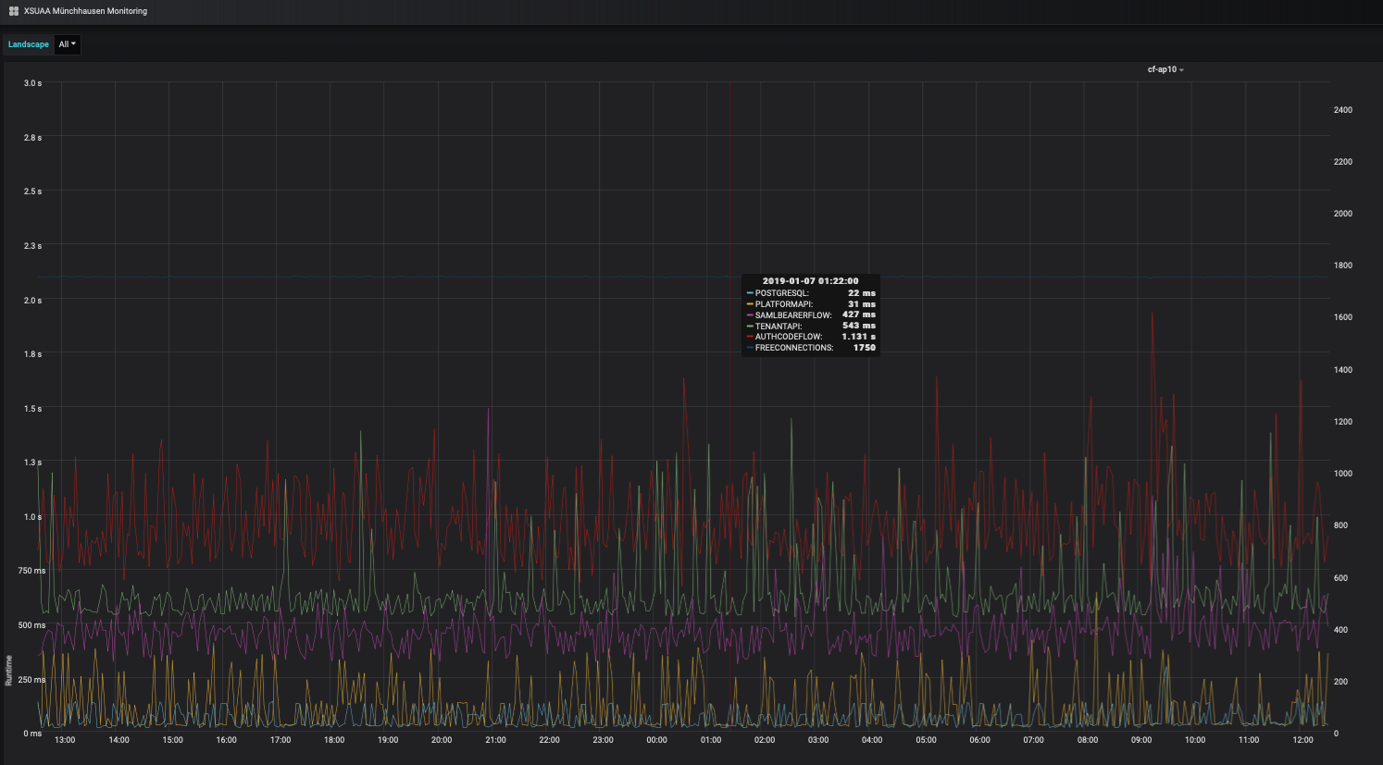For ex:**cf-ap11**: Here is how a normal operation should look like: There shouldn’t be any large intervals with high peaks for over 1-2 seconds for AUTHCODEFLOW

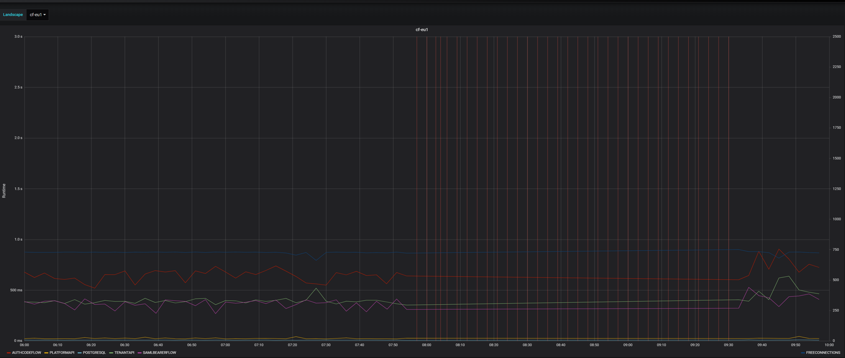 You can compare the graph with a non-working example below. The vertical lines at the second half of the screen(red lines) show that there was an issue from 08:00 until 09:30.

**2.Check the Postgress health**

Once choosen the right landscpae in grafana, then you can filter the Postgress chart by clicking the “Postgress” button at the bottom left corner 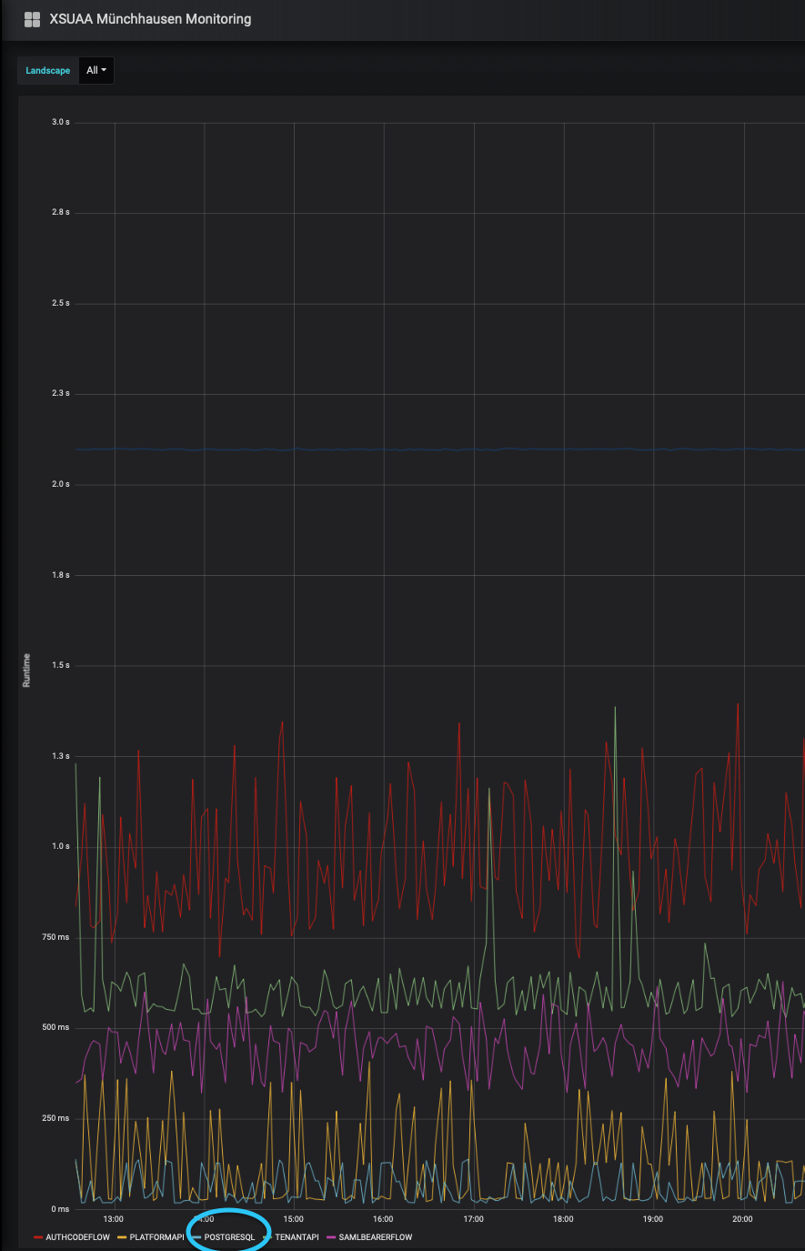

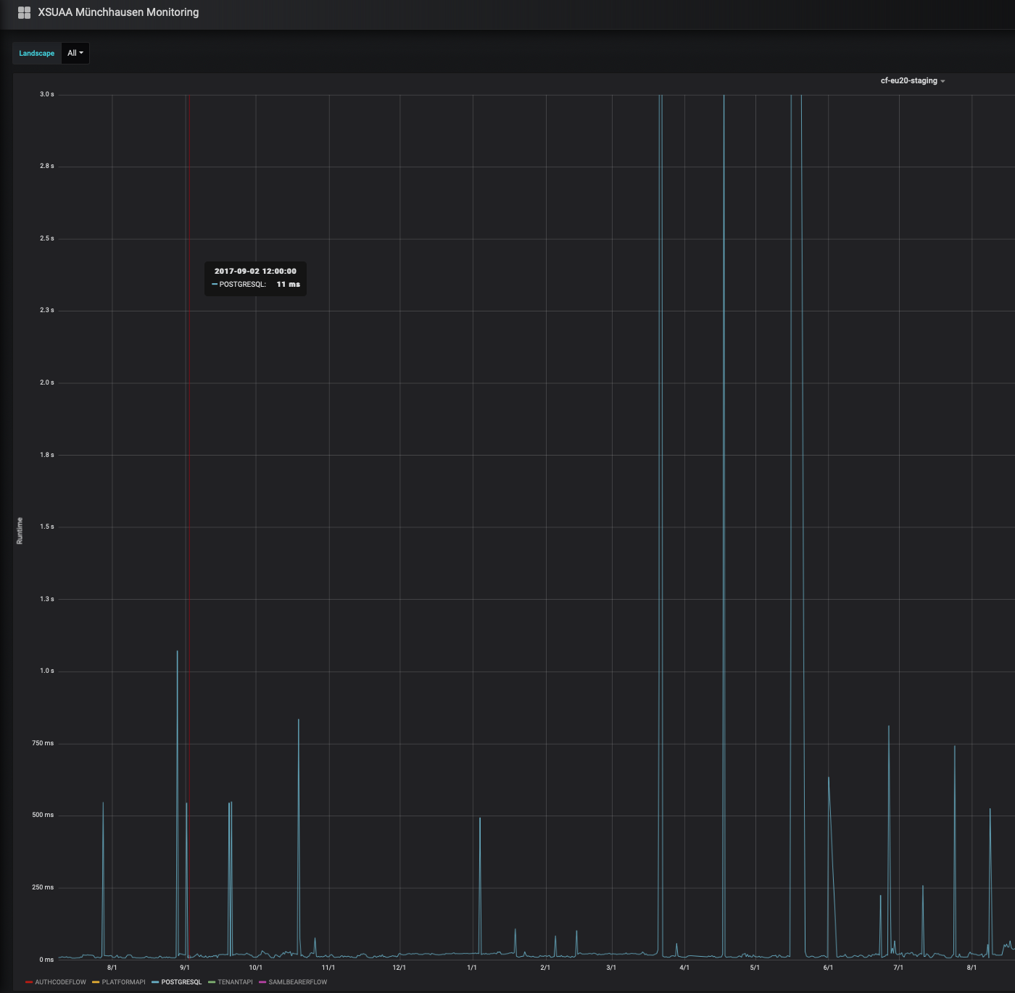

Any peak over 1 second or ANY interruptions are a sign of Database unresponsiveness in this situation - Inform CE on Duty and add Postgres SQL Team to the notification(DL Postgres-aaS Developers [DL_56C55B257BCF84B4D5000107@sap.com](mailto:DL_56C55B257BCF84B4D5000107@sap.com))

If no DB Peaks are visible proceed with next steps below

**3. Munchausen is monitoring the XSUAA service - check its Health Status**

Check the status of [CF-Munchausen ALL](https://availability.cfapps.sap.hana.ondemand.com/index.html#/evaluation/4408215/?tab=status)

Then based on the affected landscape you can see if the monitoring behind is stable:

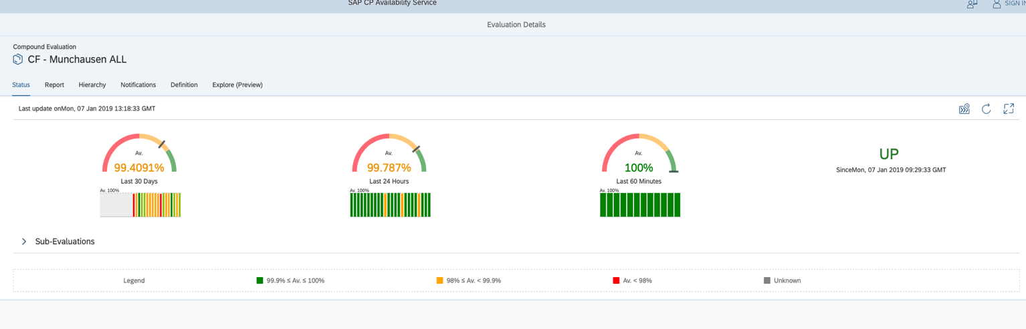

**4. Verify application URL**

You can check which component is working XSUAA or UAA by **accessing** the bellow URLs:

There is no need to login, just check if the URLs are accessible in a browser  
List of all domains can be found Here

XSUAA: https://authentication. <domain name>

UAA: https://login.cf. <domain name>

Example for **cf-eu10-canary** Landscape.

XSUAA: <https://authentication.sap.hana.ondemand.com>

UAA: <https://login.cf.sap.hana.ondemand.com>

Steps to identify and resolve the issue using cf in cli:

1. **Check application instances**

Login in to the respective landscape and target the organization. Normally they are: org **SAP_UAA** and space **prod**.

* cf api api.cf.<landscape domain> List of domains
* cf login https://api.cf.<landscape domain>
* select the respective org SAP_UAA and space : **prod**

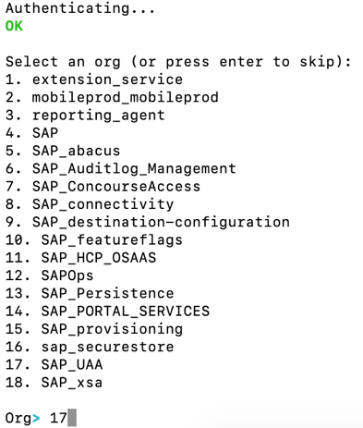

Execute “**cf apps**” to list all applications and check if the state is **“started”**. Instances column will show you how many instances are working.

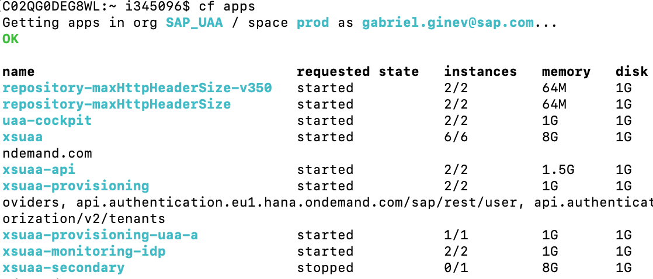

6/6 means that all 6 instances are working. 4/6 means that they are 2 not working instances.

!Keep in mind that even “**cf apps**” shows xsuaa as “started”, this does not mean implicitly that all xsuaa instance are running!

You can further list all application instances by running “**cf app xsuaa”** command.

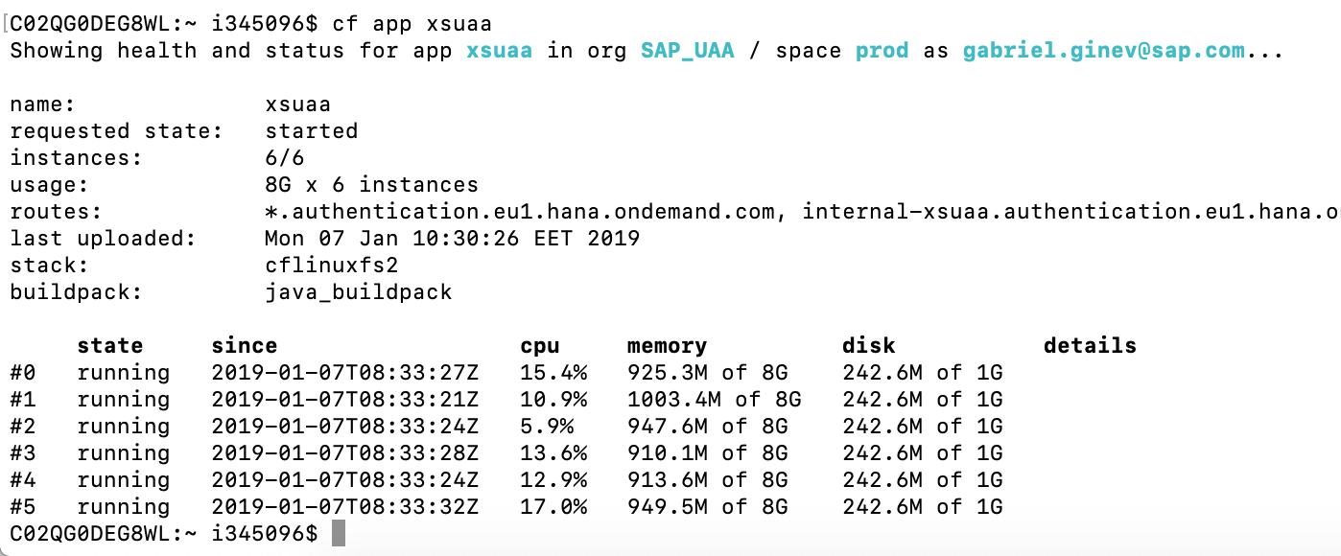 All instances should report “running” state.

1. **Check the CPU usage**

Once all application instances are listed with “**cf app xsuaa**” command, you can see the CPU usage at the 4th column. (refer to the screenshot above)It should not be over 100%

If CPU usage goes over 100%, you can further scale another 1 or 2 instances by the “**cf scale -i 8 xsuaa**” command, where “-i” is the total number of instances.

If scaling up to 2 additional ones does not recover the CPU usage, this is a sign of an application problem.

1. **Restart application instance**

If you suspect that any app instance from the above list does not respond, you may then restart it.

The below command will do the trick:

**cf restart-app-instance xsuaa <ID>**

Example:

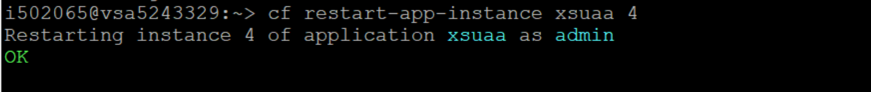

1. **Don’t forget to logout**

When finishing with the command line, you should logout. Otherwise your cf login session to the specific landscape will remain.

So next time when you execute any commands you can accidentally run them against the wrong landscape !

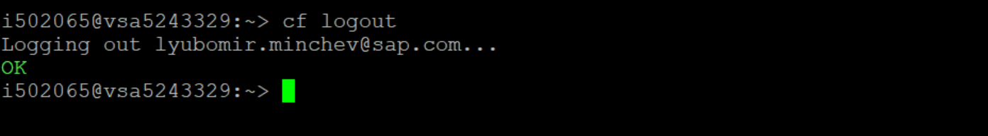

# **Steps to handover the Incident:**

1. Inform [[CE On Duty](https://wiki.wdf.sap.corp/wiki/x/th_Uag)](https://wiki.wdf.sap.corp/wiki/display/EngSrv/30+CE+Engineer+on+Duty) with the relevant details like Landscape and Service name that is impacted.
2. Update the SPC with relevant findings while executing the RA

# List All CF Landscapes

|  |  |  |  |  |  |  |  |  |  |  |
| --- | --- | --- | --- | --- | --- | --- | --- | --- | --- | --- |
| LANDSCAPE-ID | TYPE | DESCRIPTION | OWNER | JUMPBOX IP | DOMAIN |  |  |  |  |  |
| +--------------------+-------+--------------------------------+---------------+-----------------+----------------------------------------+ | | | | | | | | | | |
| | cf-ap10            | aws   | Asia Pacific (Sydney)          | sic@sap.com   | 13.55.57.30     |ap10.hana.ondemand.com | | | | | | | | | | |
| | cf-ap11            | aws   | Asia Pacific (Singapore)       | sic@sap.com   | 13.251.74.52    | ap11.hana.ondemand.com | | | | | | | | | | |
| | cf-br10            | aws   | Brazil (São Paulo)             | sic@sap.com   | 18.231.67.130   |br10.hana.ondemand.com | | | | | | | | | | |
| | cf-ca10            | aws   | Canada (Montreal)              | sic@sap.com   | 35.183.216.196  | ca10.hana.ondemand.com | | | | | | | | | | |
| | cf-eu1             | sc7   | sc7 landscape                  | sic@sap.com   | 172.18.113.25   | eu1.hana.ondemand.com | | | | | | | | | | |
| | cf-eu10            | aws   | Europe (Frankfurt)             | sic@sap.com   | 18.195.99.177   | eu10.hana.ondemand.com | | | | | | | | | | |
| | cf-eu10-canary     | aws   | Europe (Frankfurt) - Canary    | all           | 35.158.149.138  | sap.hana.ondemand.com | | | | | | | | | | |
| | cf-eu20            | azure | Europe West                    | sic@sap.com   | 13.95.81.184    | eu20.hana.ondemand.com | | | | | | | | | | |
| | cf-eu30            | gcp   | europe-west3-Frankfurt         | D032991       | 35.234.86.246   | eu30.hana.ondemand.com | | | | | | | | | | |
| | cf-jp10            | aws   | Japan (Tokyo)                  | sic@sap.com   | 54.95.90.37     | jp10.hana.ondemand.com | | | | | | | | | | |
| | cf-us10            | aws   | US East (VA)                   | sic@sap.com   | 34.227.144.30   | us10.hana.ondemand.com | | | | | | | | | | |
| | cf-us30            | gcp   | us-central1 Iowa               | sic@sap.com   | 104.198.163.205 | us30.hana.ondemand.com | | | | | | | | | | |